Defining the Application Architecture

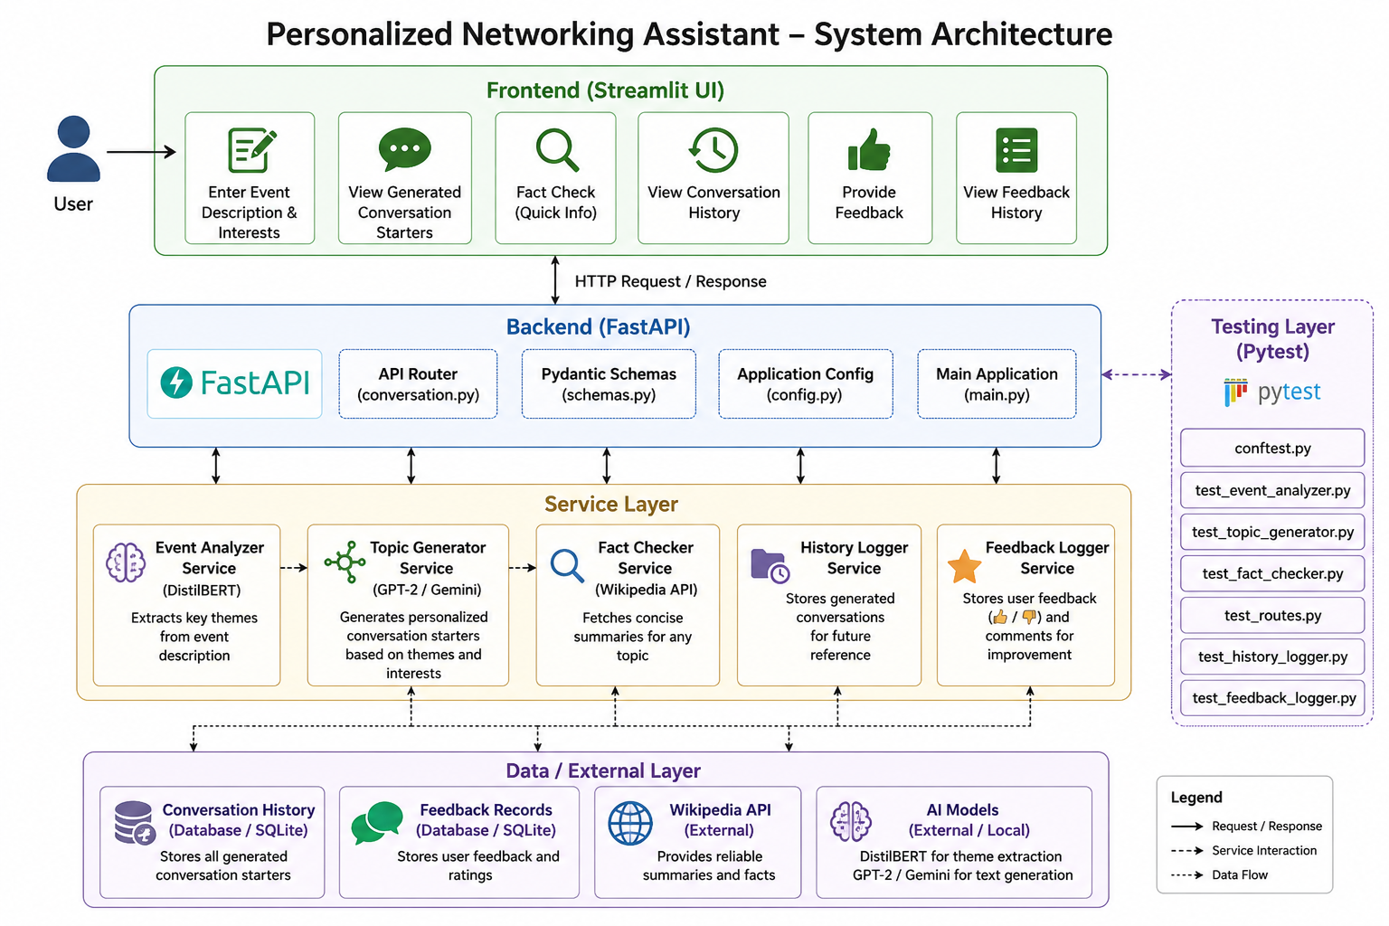
Description:

The Personalized Networking Assistant follows a three-tier architecture consisting of the Presentation, Application, and Service layers. The Streamlit frontend collects user input and displays results, while the FastAPI backend processes requests and routes them to the appropriate services. The service layer includes DistilBERT for theme extraction, GPT-2 for conversation generation, the Wikipedia API for fact checking, and modules for managing history and feedback. This modular architecture ensures scalability, maintainability, and reliable performance through Pytest testing.

